Final Project Report

<< Virtual University Campus Event Management System (VUCEMS) >>



Project Supervisor
<< Hafiz Muhammad Azeem Sarwar >>

Submitted By

<< F25PROJECT809A4>>

<< MAZHAR JAVED>> << BC230401227>>

Software Projects & Research Section,
Department of Computer Sciences,
Virtual University of Pakistan


CERTIFICATE

This is to certify that << MAZHAR JAVED>> (<<BC230401227>>) has worked on and completed their Software Project at Software & Research Projects Section, Department of Computer Sciences, Virtual University of Pakistan in partial fulfillment of the requirement for the degree of BS in Computer Sciences under my guidance and supervision.

In our opinion, it is satisfactory and up to the mark and therefore fulfills the requirements of BS in Computer Sciences.

Supervisor / Internal Examiner

<< Hafiz Muhammad Azeem Sarwar >>
Supervisor,
Software Projects & Research Section,
Department of Computer Sciences
Virtual University of Pakistan

___________________
(Signature)

External Examiner/Subject Specialist
<<External Supervisor Name>>

___________________
(Signature)

Accepted By:

_____________
(For office use)

EXORDIUM

In the name of Allah, the Compassionate, the Merciful.

Praise be to Allah, Lord of Creation,
The Compassionate, the Merciful,
King of Judgment-day!

You alone we worship, and to You alone we pray for help,
Guide us to the straight path

The path of those who You have favored,

Not of those who have incurred Your wrath,
Nor of those who have gone astray.

DEDICATION

The completed work to be devoted to someone closer to you e.g., Mother, Father etc.

ACKNOWLEDGEMENT

Thankfulness to your loved ones for their support in the completeness of the project.

PREFACE

Represents Scope and Aim.

TABLE OF CONTENTS

CHAPTER NO. 1
Software requirements specification (SRS Document)

1.1 scope
1.2 Functional & non-fucntional)
1.3 Use Case Diagram
1.4 Work Plan (Use MS Project to create Schedule/Work Plan)

CHAPTER NO. 2
designing the project (Design Document)
2.1 Introduction of Design Document
2.2 Data Flow Diagram (DFD)
2.3 Entity Relationship Diagram (ERD)
2.4 Database Design
2.5 Interface Design

<<Dear Students, before starting each chapter the following would be the title page for each chapter on a separate page>>

CHAPTER 1
SOFTWARE REQUIREMENTS SPECIFICATION (SRS DOCUMENT)

1.1 Scope of Project:

The scope of the Virtual University Campus Event Management System (VUCEMS) is to provide an easy and centralized web-based platform for managing university events. The system will allow faculty and staff to create, update, and manage events, while students can view, search, and register for upcoming events. It will support different event types such as webinars, workshops, seminars, and cultural activities. The system will also handle user authentication, email notifications, and event feedback. Administrators will manage users, event categories, and system-wide reports. Overall, VUCEMS aims to improve event coordination, increase student participation, and reduce manual work in event management.

1.2 Functional and non Functional Requirements:

Functional Requirements
Public/Guest User
- Ability to view upcoming and active events.
- View detailed information for any event.
- Search and filter events by category, name, or date.
Student User
- Secure registration and login.
- Student dashboard showing registered events and suggestions.
- One-click event registration.
- View registration history.
- Receive email confirmation and reminders.
- Submit feedback for attended events.
Event Organizer / Faculty
- Secure login with organizer privileges.
- Create new events with full details (title, date, time, venue/link, capacity).
- Manage events (Create, Read, Update, Delete).
- View student registrations and export lists (CSV).
- Organizer dashboard with event statistics and feedback summary.
Administrator
- Full access to all organizer features.
- Manage users (view, edit, delete student/organizer accounts).
- Manage event categories (add, update, delete).
- View system-wide analytics (registrations, popular categories, event performance).
Non-Functional Requirements
Performance Requirements
- The system should load event listings within 3–5 seconds.
- Support multiple concurrent users without performance degradation.
- Efficient search and filtering within milliseconds.
Security Requirements
- User data must be encrypted and securely stored.
- Authentication using secure password hashing.
- Role-based access control (Student, Organizer, Admin).
- Prevent unauthorized access to restricted pages.
Usability Requirements
- Interface should be intuitive, responsive, and accessible.
- Mobile-friendly design for all user types.
- Clear navigation with consistent layouts.
Reliability & Availability
- System should maintain at least 99% uptime.
- Automatic recovery from common server errors.
- Regular backups of event and user data.
Maintainability
- Codebase should follow Laravel standards and modular structure.
- Easy to update event categories, user roles, and system settings.
Scalability
- System should handle an increasing number of events and users.
- Database optimized for growth and future expansions.

1.3 Use Case Diagram

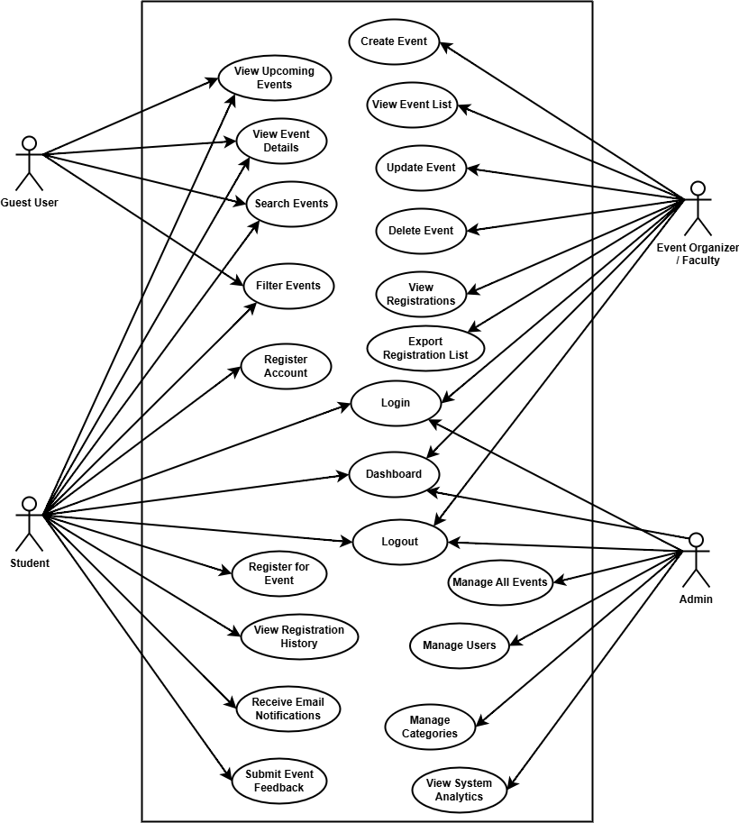

1.4 Work Plan (Use MS Project to create Schedule/Work Plan)

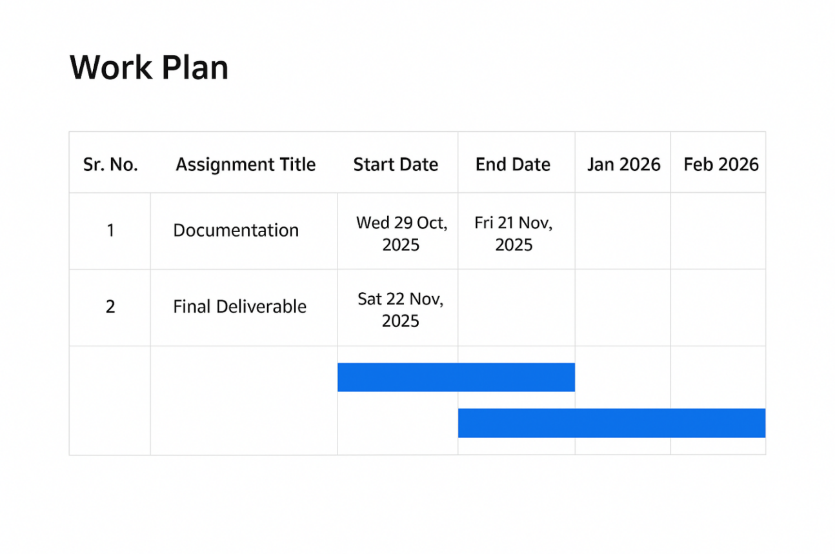

CHAPTER 2
Designing the Project
(Design Document)

  - Introduction of Design Document
This Design Document provides a clear and structured overview of the Virtual University Campus Event Management System (VUCEMS). It explains the system architecture, design approach, and main components required to build the application. The document describes how different users students, faculty/event organizers, and administrators will interact with the system. It also outlines the data flow, database design, and user interface structure to ensure smooth event management and user experience. This document serves as a guide for developers and stakeholders to understand the system design and to ensure that development is carried out in a consistent and organized manner.

  - Data Flow Diagram (DFD) (To be developed using Microsoft Visio or any other drawing software of your choice)

Level 0: Context Diagram
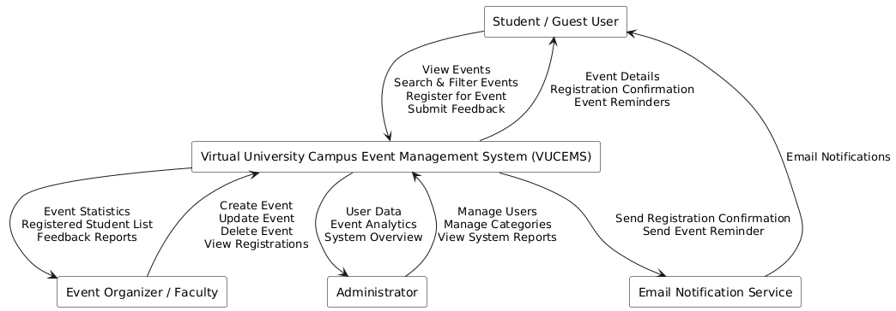
Level 1: Data Flow Diagram
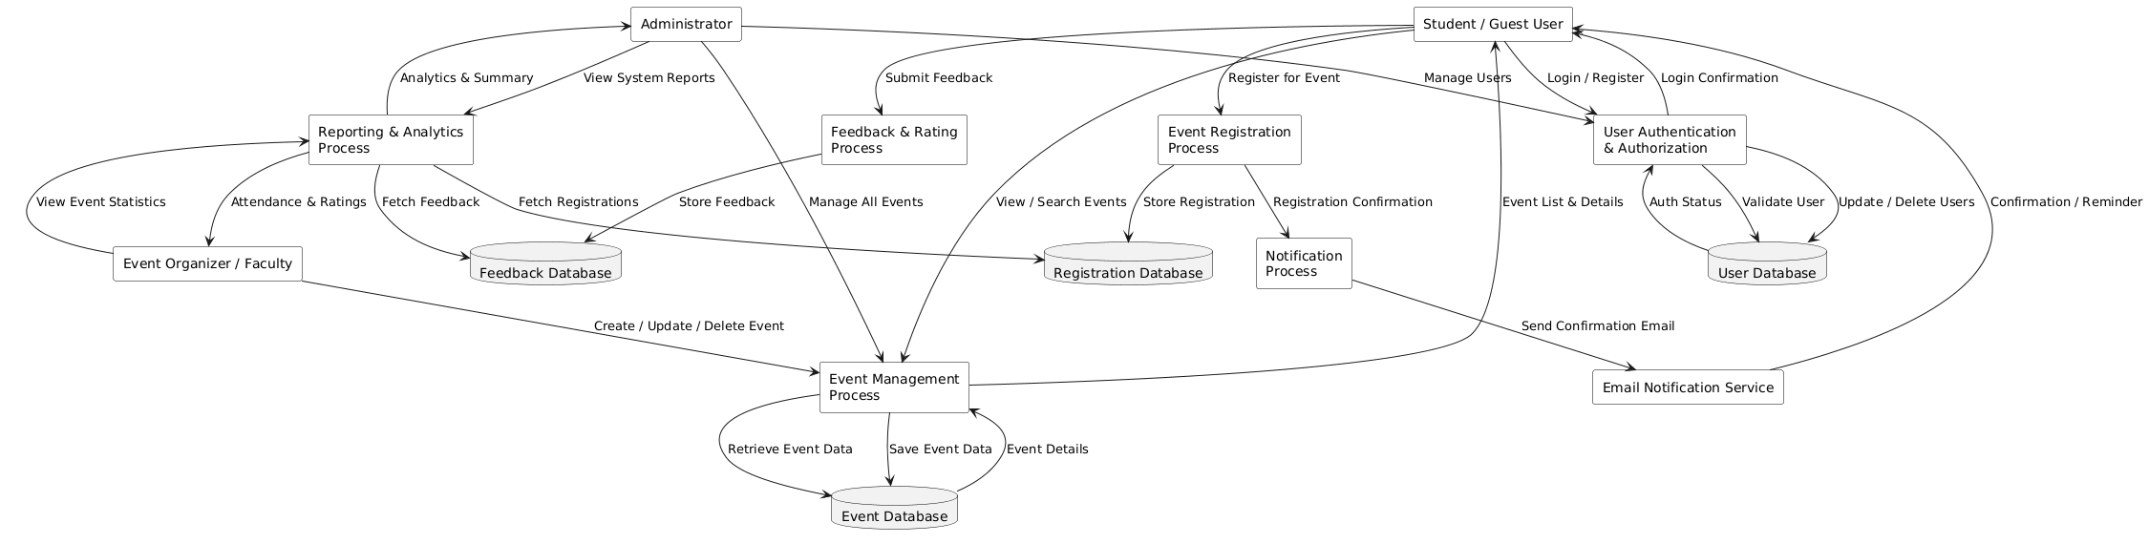

  - Entity Relationship Diagram (ERD) (To be developed using Microsoft Visio or any other drawing software of your choice)

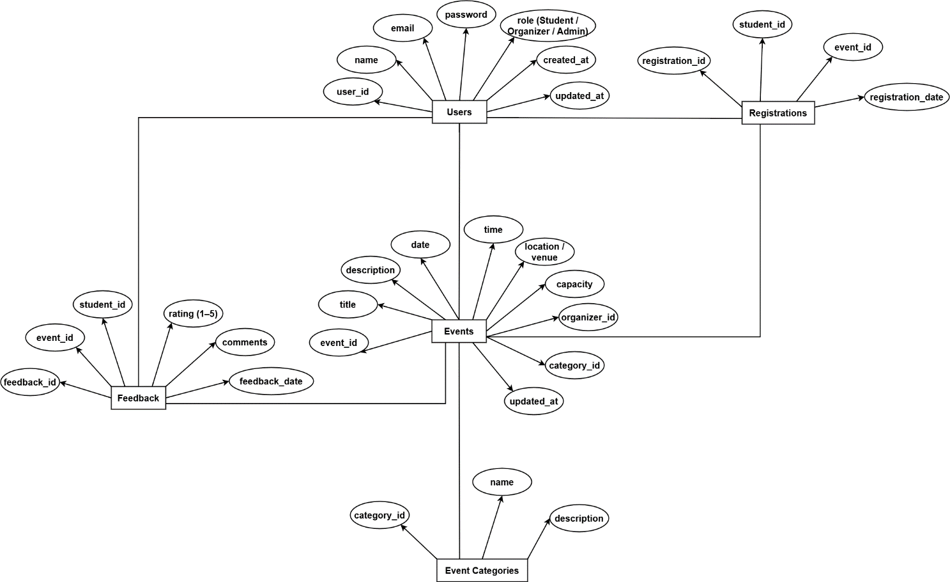

  - Database Design

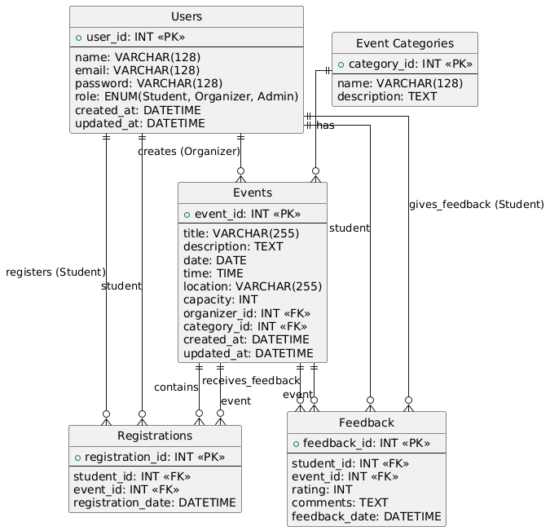

  - Interface Design (Optional)

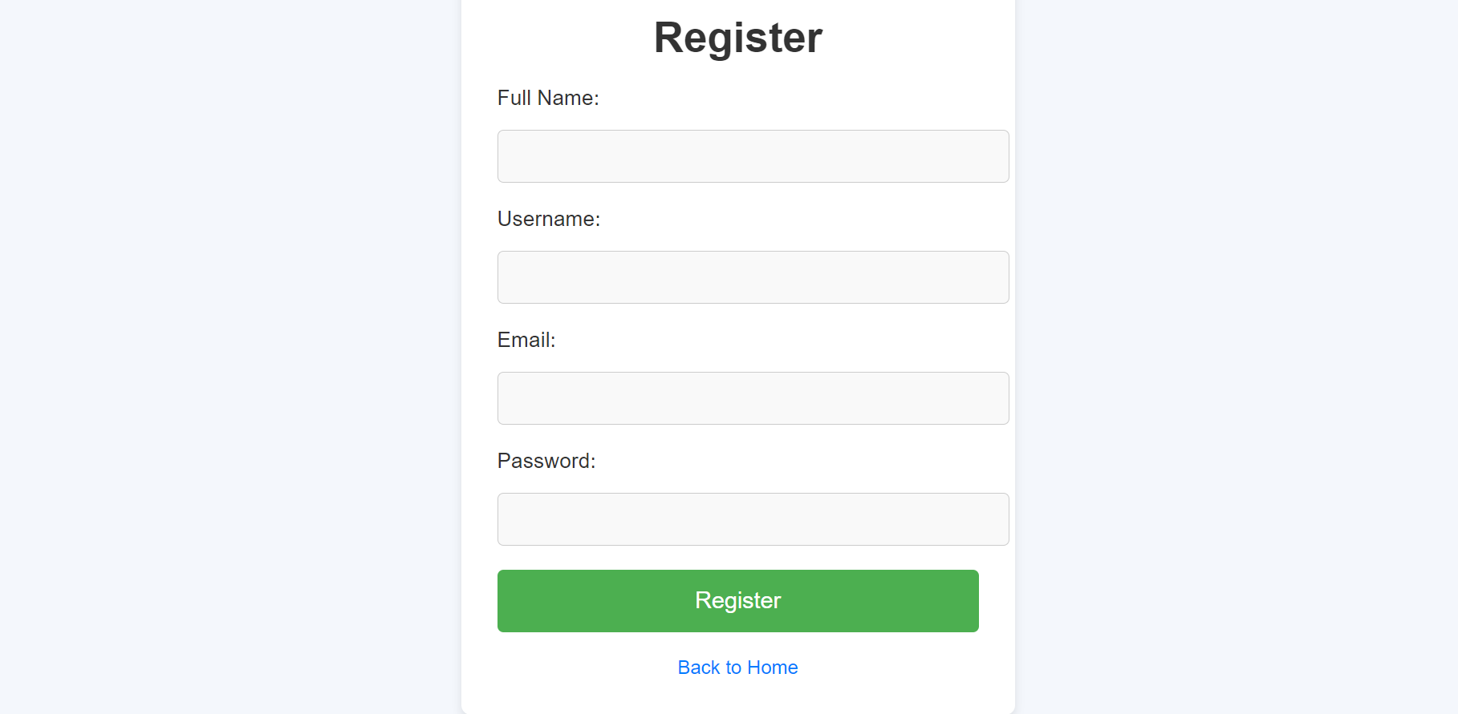

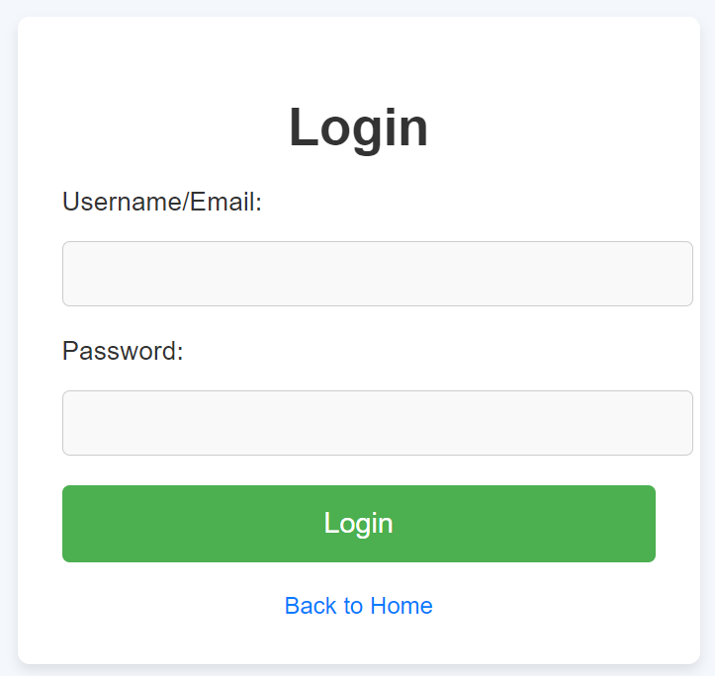

REFERENCES

APPENDIX

Supplementary Material

